Slow-Roll Parameters for Different Inflationary Model Scenarios
The following section comprises of expected slow-roll parameter values, CMB observable values for a given model from Planck constraints, and the given potential used explicitly. For each of these scenarios the parameters were calculated three different ways before then generating a model using the modified Monte Carlo reconstruction code. All Planck constraints for the specified model come from this paper starting from Section 6 (Page 13/65), specifics for each model follow in section 6.2. Dope plot worth kind of trying to mimic in Figure 12, page 18.
In general, that section tells us that:
To first order
ϵ1 < 0.0068 (95%)
ϵ1 = 0.029 (+0.008 or -0.007) so, 0.022 < ϵ1 < 0.037 (68%)

With high polarization included:
ϵ1 < 0.0066 (95%)
ϵ1 = 0.03 (+0.007 or -0.006)

The predictions to lowest order in the slow-roll approximation for ns and r assume k=0.002 Mpc^-1 and as usual end of inflation is assumed where eps=1.

Higgs

Our ideal model.
https://arxiv.org/abs/1907.00993
https://arxiv.org/pdf/2002.11739

Slow-Roll Parameters | 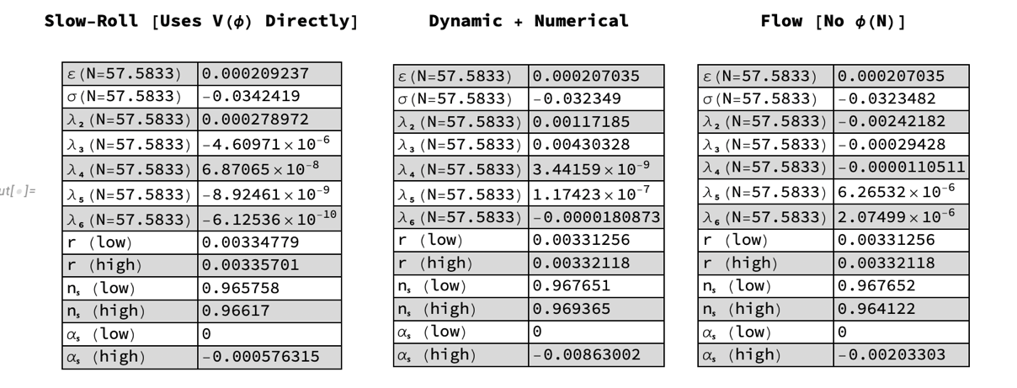
Expected Observables
Potential Used

Starobinsky  Characterized by a flat plateau, and predicts nearly scale invariant index and small r. Original motivation was to include quantum effects at one loop and includes some R^2 corrections due to gravity.  https://www.sciencedirect.com/science/article/abs/pii/037026938090670X  https://academic.oup.com/ptep/article/2014/6/06B103/1562252 |  | 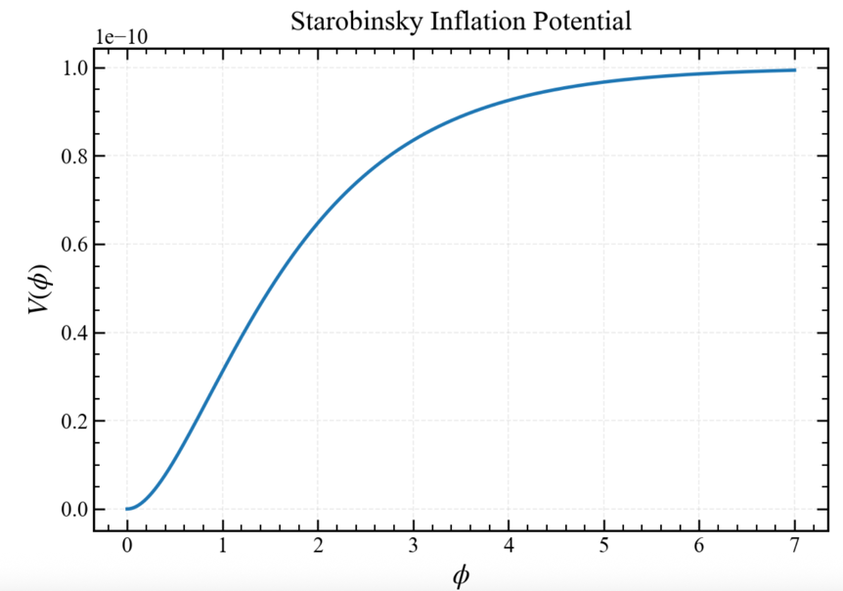
Slow-Roll Parameters | 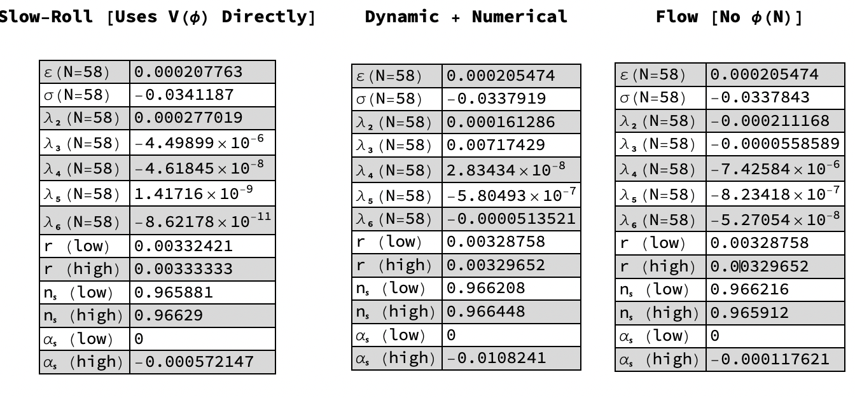
Expected Observables
Potential Used | V(φ) = Λ^4 (1−e^(−(√2/3)φ/Mpl))

Alpha-T  An additional class characterized by having a plateau introduced for various reasons.  https://arxiv.org/abs/1311.0472 |  | 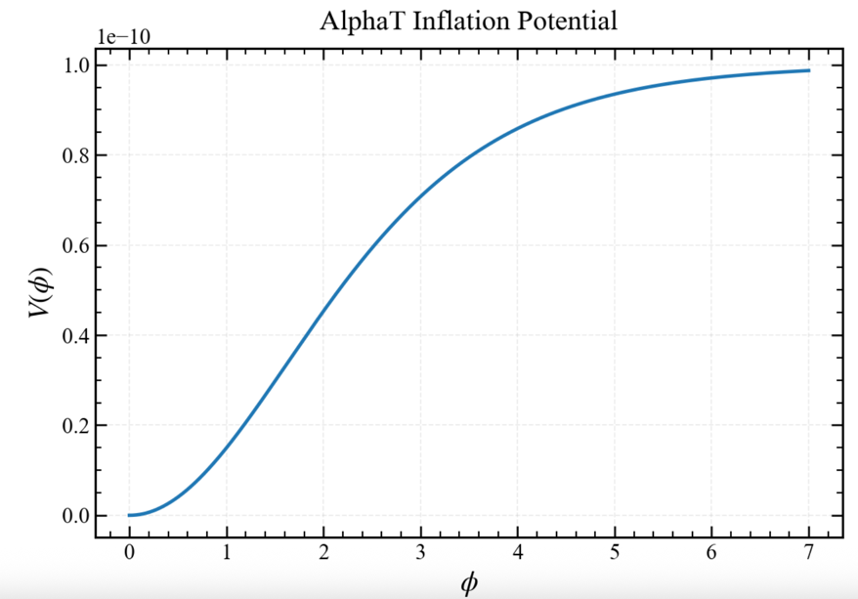
Slow-Roll Parameters | 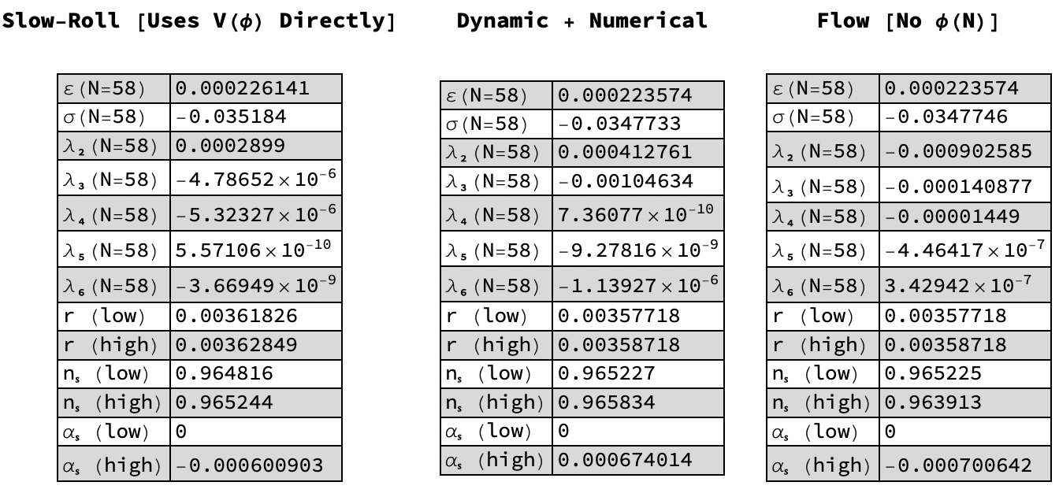
Expected Observables
Potential Used | V(φ) = Λ^4 tanh^(2m)(|phi/sqrt(6\alpha) Mpl|) OR V(φ) = Λ4 (1−e−√2φ/ √3αMpl)^2

Hilltop  Assumes inflation takes place near a maximum of the potential. The inflaton field rolls away from an unstable equilibrium.  https://arxiv.org/abs/hep-ph/0502047 |  | 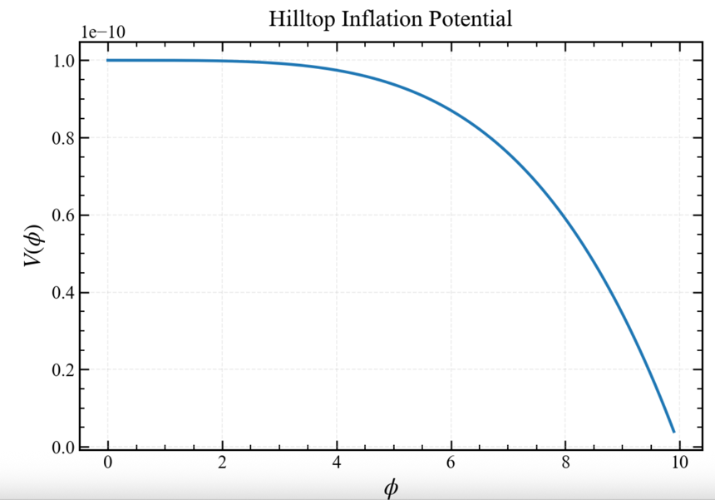
Slow-Roll Parameters | 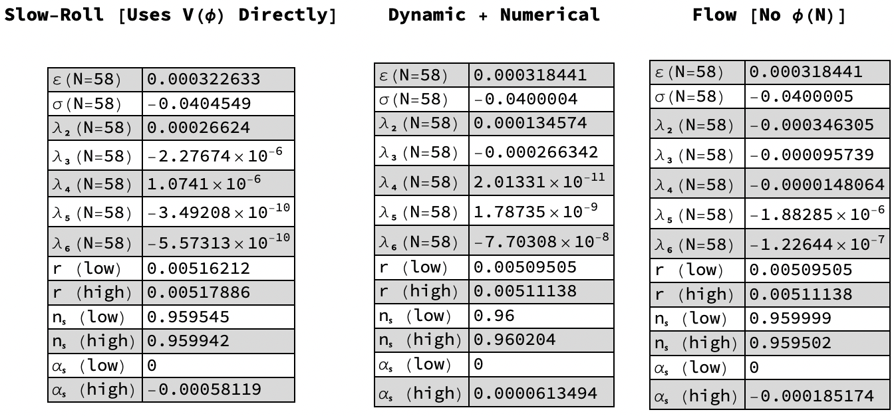
Expected Observables
Potential Used | V(φ) = V0 – 1/  2 m^2 φ^2 + = Λ^4 (1−  Φp / µp)

Quad (Deformed)  Similar to quadratic model with minimal higher order correction.  https://arxiv.org/abs/2511.05341 |  | 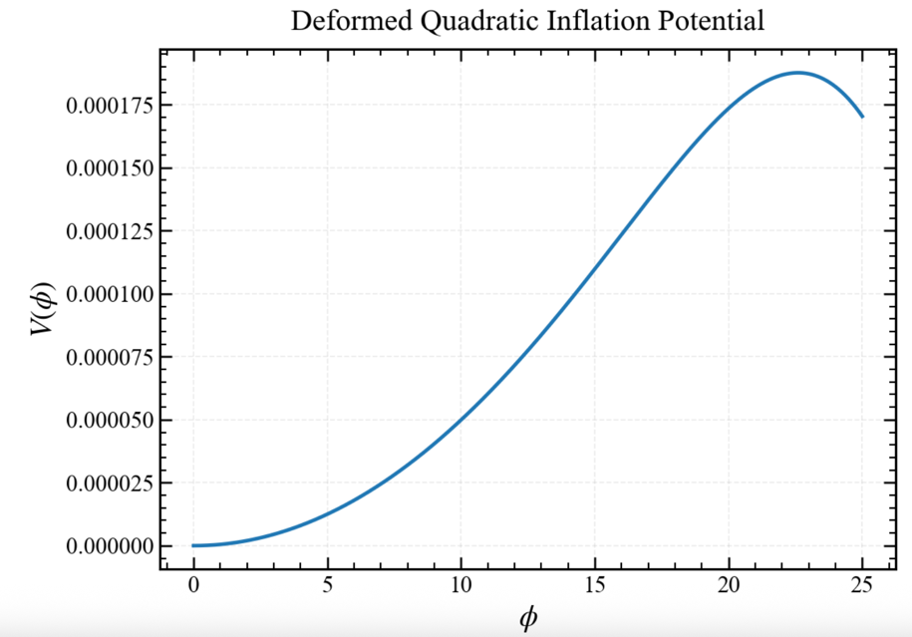
Slow-Roll Parameters | 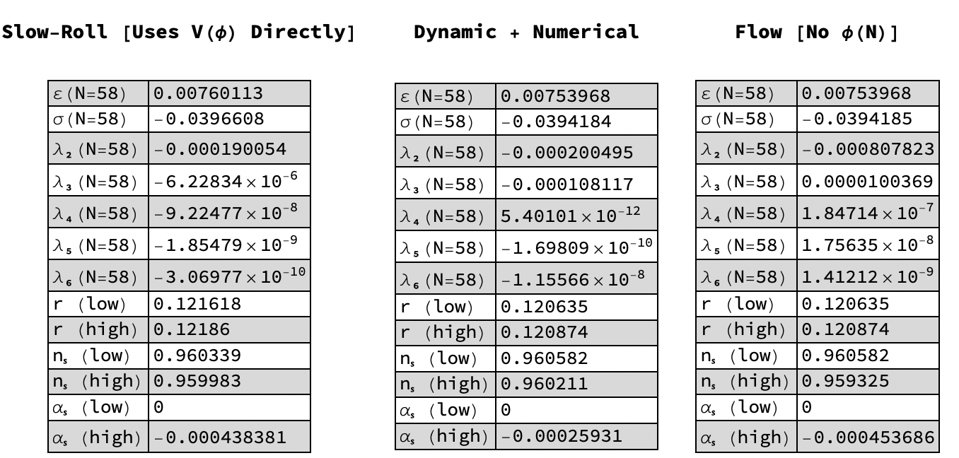
Expected Observables
Potential Used

Natural  Natural inflation is naturally flat in order to meet expectations from CMB. It is a model that enhances the power of the potential on large scales. Aimed to try and describe large scale clustering of galaxies.  https://arxiv.org/abs/astro-ph/9310012  https://ui.adsabs.harvard.edu/abs/1993PhRvD..47..426A/abstract |  | 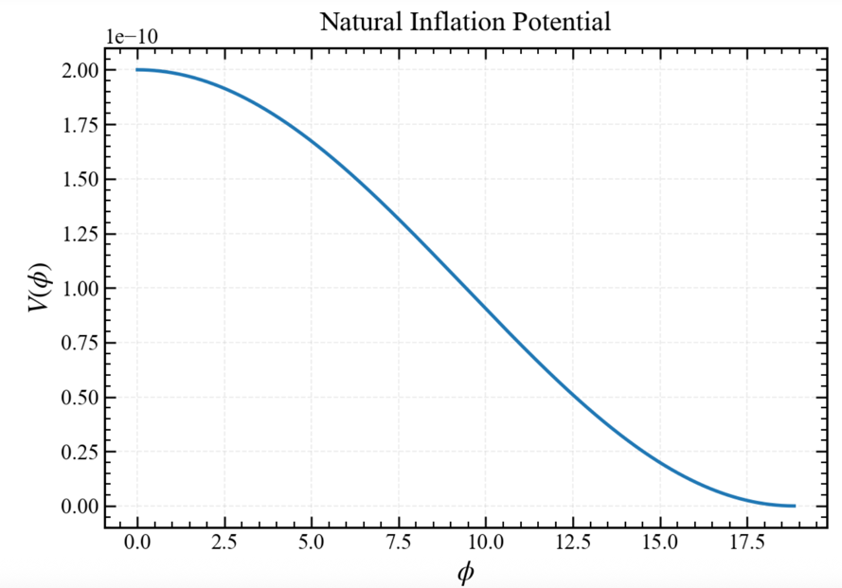
Slow-Roll Parameters | 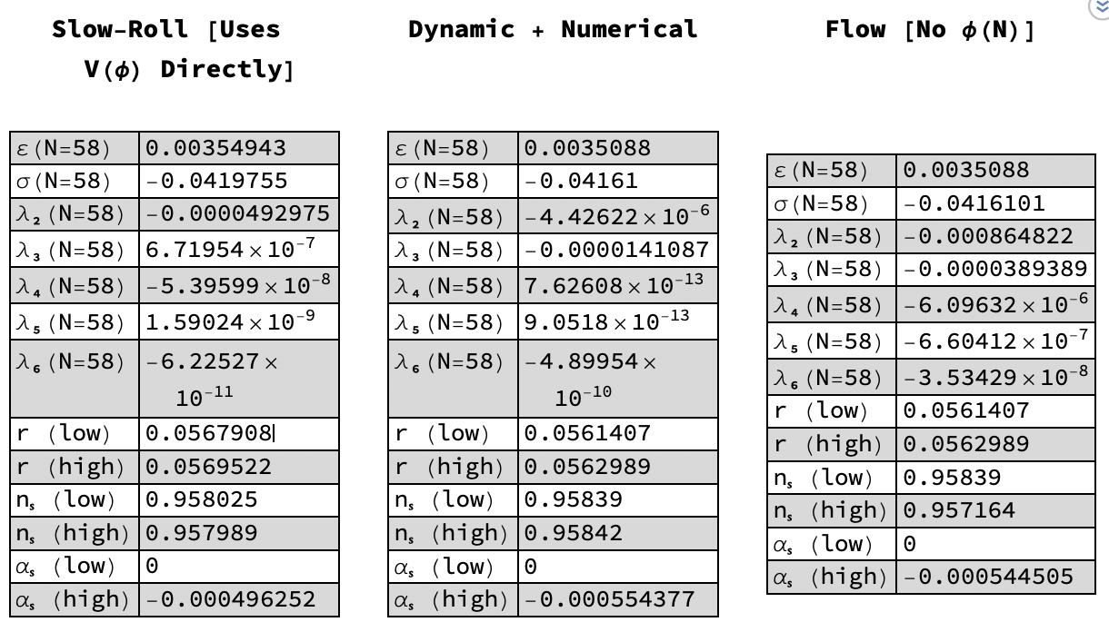
Expected Observables
Potential Used | V(φ)=Λ⁴[1+/-cos(φ/f)]

